Steps for Purchasing Goods at Babson
We define procuring goods as tangible items for purchase. There are exceptions to this list.
Procuring Goods Process
- When procuring goods under $10,000 at the College, a Babson PCard can be used for purchase.

- When procuring goods over $10,000, submit a requisition in Workday for purchase.

- We want to make sure purchases are competitively bid, so please shop around, when permissible. Attach three (3) competitive quotes from different suppliers or a no-bid-exception form as supporting documentation during your submission.
Workday Submission
- Doing business with Supplier for the first time? Make sure the supplier is set up in the Workday system. If not, submit a Create Supplier Request task in Workday. This will route to Accounts Payable for approval.

- Once complete, submit a request using the Request Non-Catalog Items task in Workday and select Request Goods.
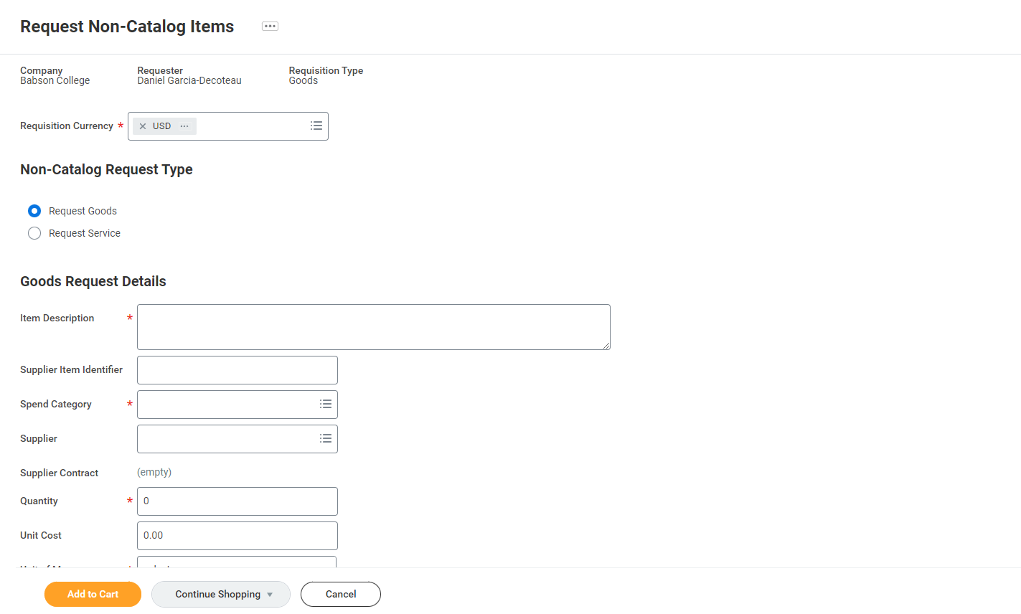
- Once the submission is approved in Workday, Procurement will generate a Purchase Order (for orders over 10K).

- The final step is to pay the supplier once goods are received. Submit a supplier invoice payment using the Create Supplier Invoice Request task in Workday. Please reference your PO number during your submission. This will route to Accounts Payable for approval and settlement.
Please refer to resources below for more information
- Bid-Exception Form- no-bid-exception-form.docx (live.com)
- Procurement Card Application- PCARD-Application.pdf (babson.edu)
- Procurement Card Agreement- Procurement-Cardholder-Agreement.pdf (babson.edu)
Contact Procurement with any questions about this process at
procurement@babson.edu

